# CS 255 System Design Document Template

This template lays out all the different sections that you need to complete for Project Two. Each section has guidance to prompt your thinking. You will need to continually reference the interview transcript as you work to make sure that you are addressing your client’s needs. There is no required length for the final document. Instead, the goal is to complete each section based on what your client’s needs are. Remove this note when you are finished and replace all bracketed text with the relevant information.

## UML Diagrams

## UML Use Case Diagram

### UML Activity Diagrams

User Login Activity Diagram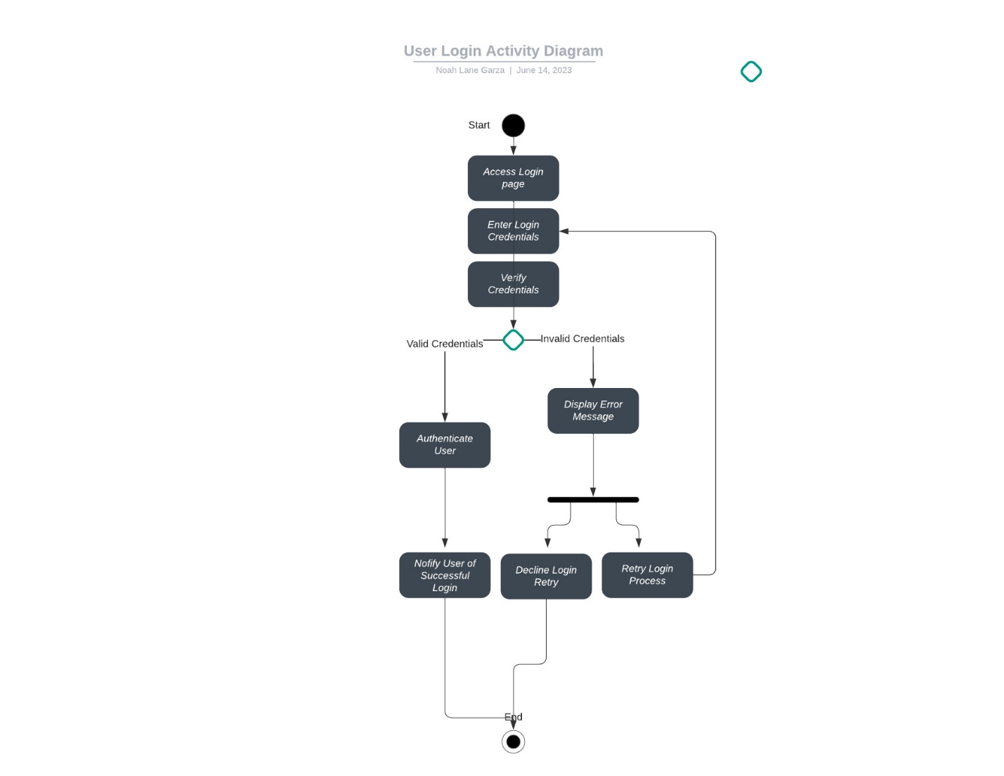

### Appointment Activity Diagram

### UML Sequence Diagram

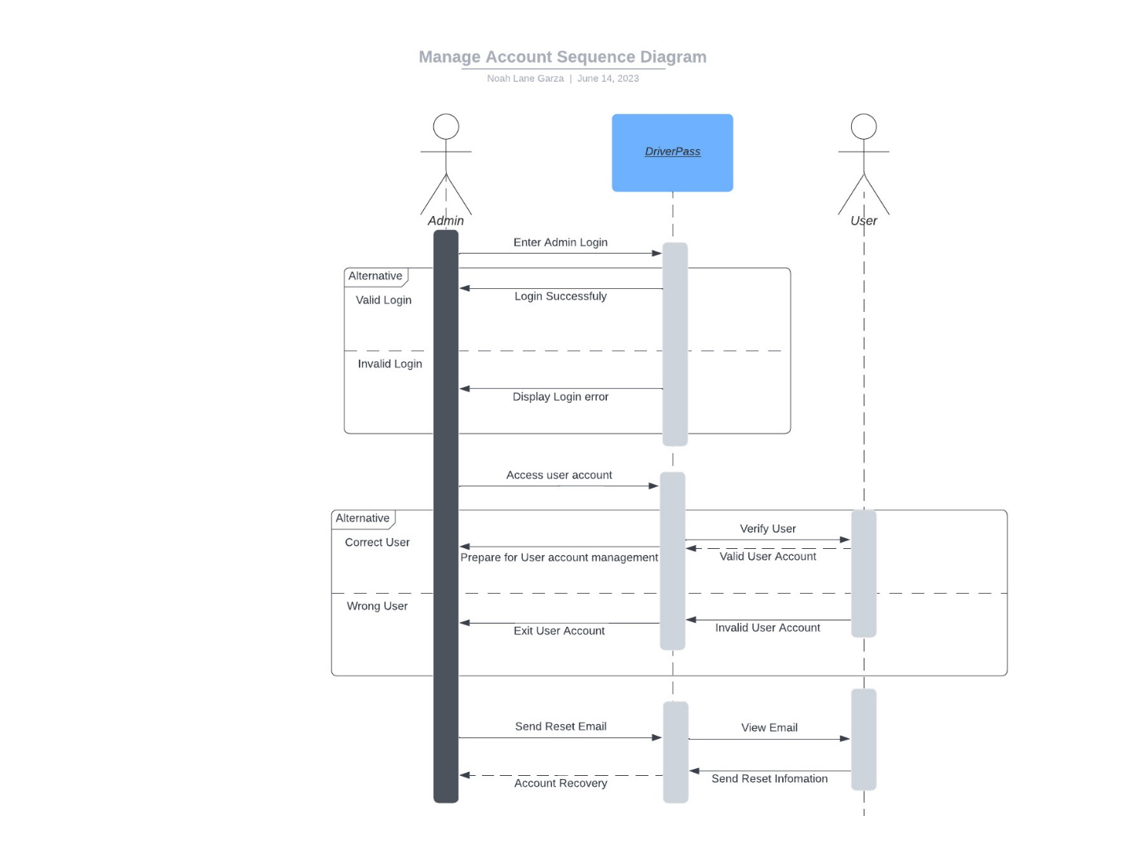

### UML Class Diagram

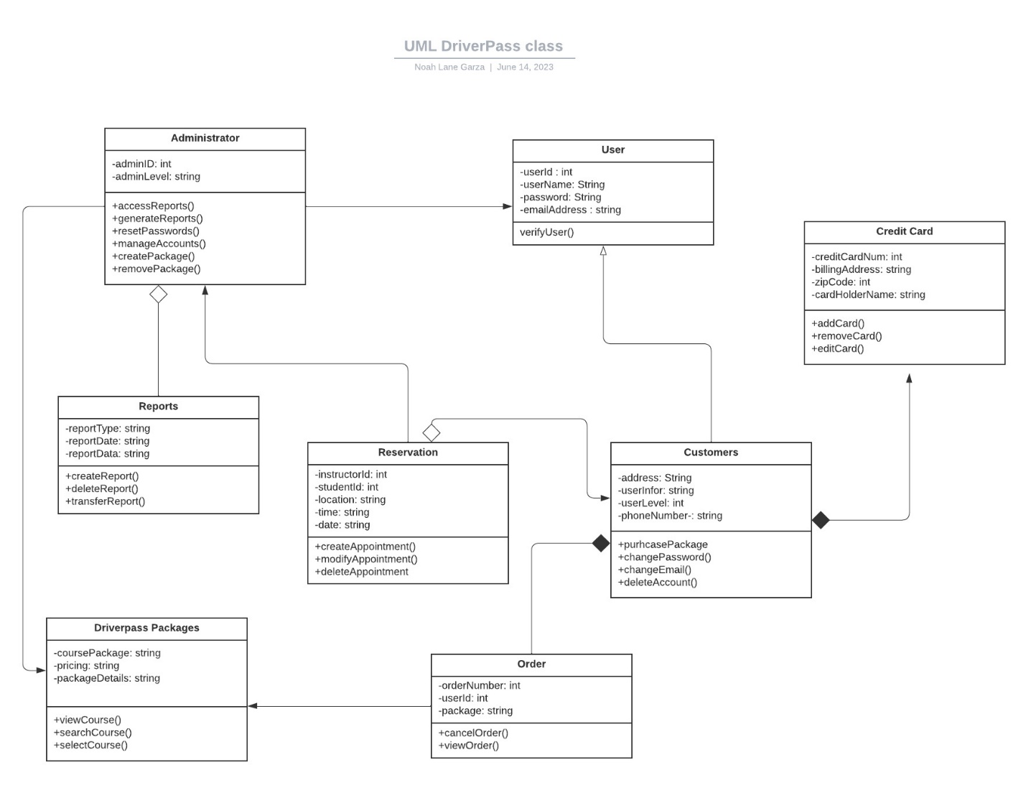

## Technical Requirements

***Hardware Requirements***

* Monitoring systems, Computers, computer mouse, phones, etc.
* Fast and reliable internet connection
* Backup for data recovery solutions in case of emergency

***Software Requirements***

* Web application to provide access to the DriverPass system.
* Operating system for the servers
* Programming languages
* Integrated Development Environment
* Security features to protect the system.

***Tool Requirements***

* UI designing tool.
* Framework testing
* Debugging and development tools
* UML diagrams (use case, activity, sequence)

***Infrastructure Required***

* Server or cloud to host the system and store data and information.
* Network infrastructure for connectivity between server and clients.